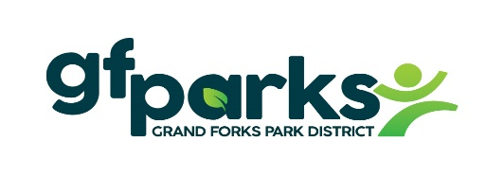

GREENEMPLOYEE/Instructions –
How to update employee payroll information and view paystubs

- GreenEmployee is the website we use for your employee payroll information.
- This is the same company we use for your GreenEmployee Onboarding when you were first hired.
- Your GreenEmployee account will not be activated until your first paycheck.
- To access your GreenEmployee account:
- Go to website www.gfparks.org – Employee Resources
- Scroll down to GreenEmployee and Click on Web Login
- Enter your Email address & Password. Or “Create an Account” if you have never created one.
This is the same email address and password for your GreenEmployee Onboarding when you were hired.
- Once you can access your account you are able to update and view many items:
  - Update address
  - Change direct deposit
  - View paystubs
  - View W-2s
  - Change payroll tax withholdings –
    - Federal W-4
    - ND W-4
    - MNW-4 and ND NDW-R form taxes withholding
- Account Settings:
    - Receive text or email notifications for paystubs.
    - Electronic Year End W-2 & 1095-C Distribution Preference

- You can Download the app: GreenEmployee Company code: Gfparks
- The GreenEmployee app only allows you to view your paystubs and W-2. You are not able to update your employee payroll information from the GreenEmployee app.

Revised: 2/7/2023

